W2D2

**Question 1. Practice Radix Sort Repeat what I have done in Slides 24 and 25. Let Radix be 9. Array to be sorted is {179, 721, 639, 549, 292, 427, 335, 435, 62}.**

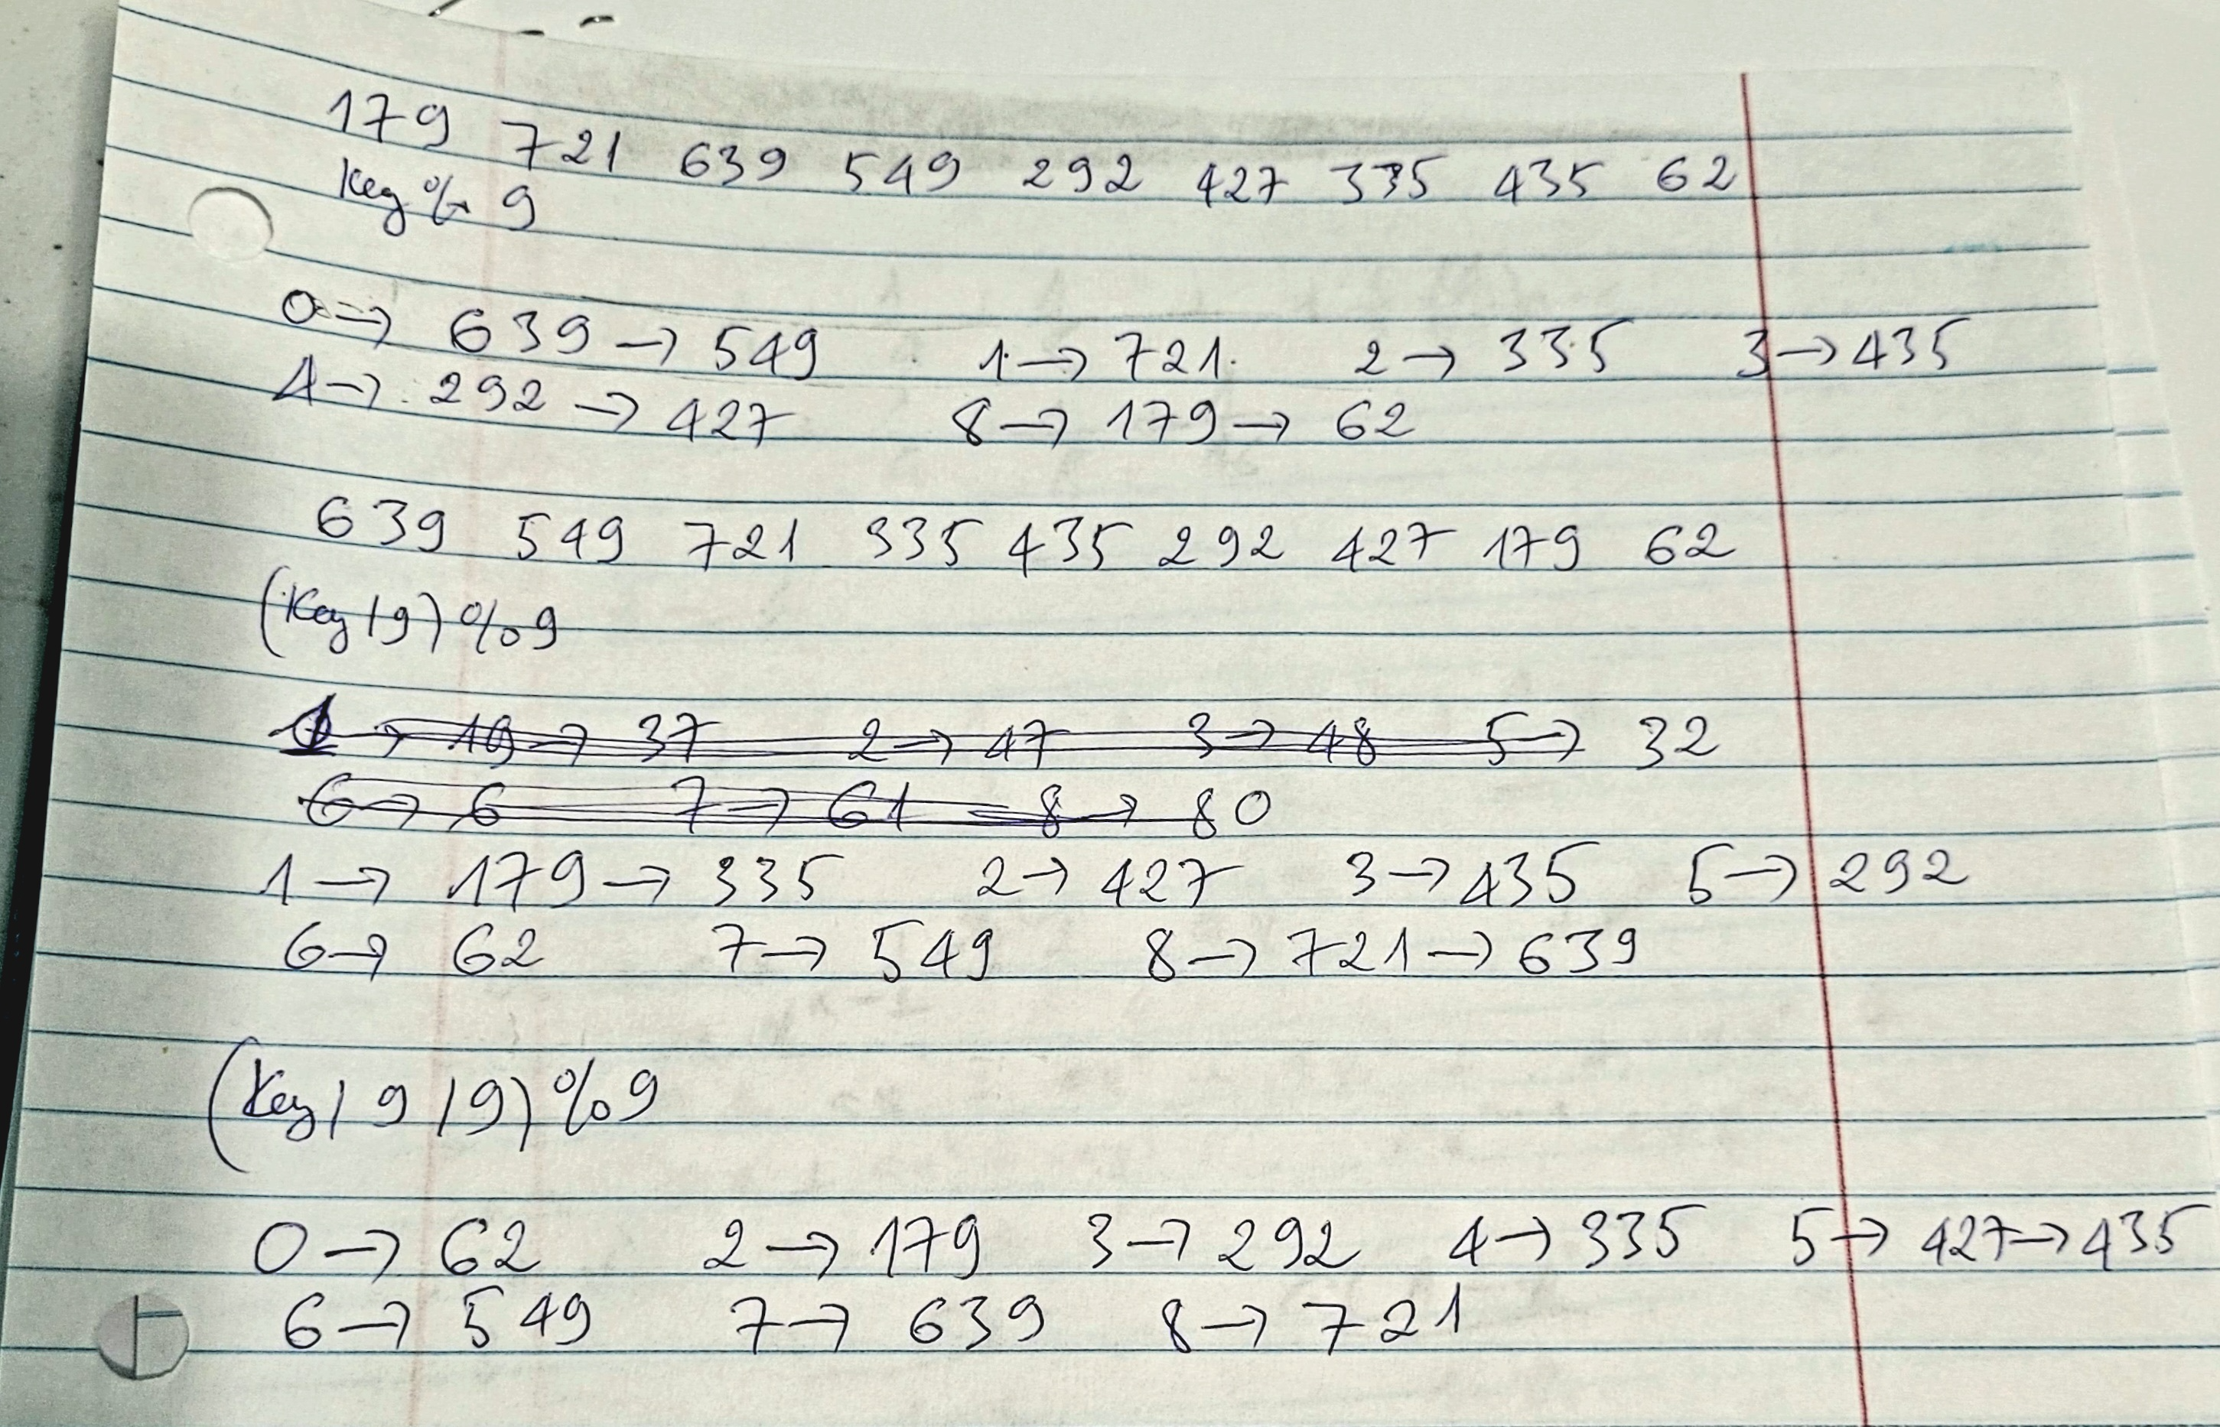

**Question 2. Experimenting with lower bound Devise an algorithm to sort 4 elements using exactly 5 comparisons in the worst case. Does this violate the theoretical lower bound? Justify your answer.**

Number of the comparison is same height of decision tree, which is log24 ~ 5, the lower bound is nlogn, but nlogn is just time complexity, which is growth of an algorithm, so it does not violate the theoretical lower bound

**Question 3. Exploring new ideas: Forward and backward sorted array (FBS array) Definition An array is said to be FBS array if it satisfies the following three conditions.**

**(1) Elements in the even locations are sorted in the ascending order.**

**(2) Elements in the odd locations are sorted in the descending order.**

**(3) Every element in the even locations are <= every element in the odd locations. Example {7, 20, 10, 19, 10, 17, 14, 15, 15} What is the asymptotic running time of your algorithm? What is the fastest possible asymptotic running time for such an algorithm? Prove your answer.**

Each condition we need O(n), so 3 condition we need O(3n), eventually it O(n)